St. Ambrose Parish was established by Most Reverend Duane G. Hunt, the fifth Bishop of Salt Lake City, on January 4, 1948. The name of the parish was chosen by Bishop Hunt to honor St. Ambrose, the early Church’s learned and scholarly Bishop of Milan, and because his Episcopal coat of arms contained a beehive, symbolic of Ambrose’s eloquence, but also the symbol of the State of Utah. The Patronal feast of the parish is December 7th commemorating the day St. Ambrose was consecrated bishop in 374.

Monsignor Joseph I. Gosselin was selected as the first pastor. Sunday Masses were first celebrated at WE-ASK-U-INN, a restaurant located on 21st South near 23rd East.  The rectory was located in a house across the street from the future church, on Hollywood Avenue.

[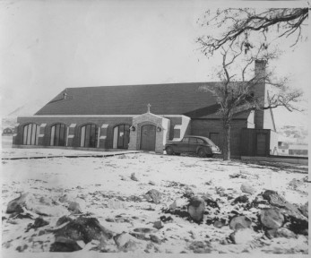](http://stambroseslc.com/wp-content/uploads/2014/03/St.-Ambrose-8A-2.jpg)

A combination church and hall was completed on the present site by November 6, 1949.

[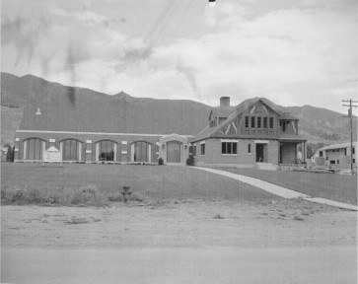](http://stambroseslc.com/wp-content/uploads/2014/03/St.-Ambrose-14-2.jpg)

The present rectory was built in 1951. With the steady expansion of the southeast bench areas of Salt Lake County, the parish gradually increased in number of parishioners. Failing health, however, took its toll on Monsignor Gosselin and he died on April 27, 1956.

[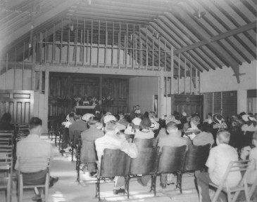](http://stambroseslc.com/wp-content/uploads/2014/03/St.-Ambrose-6A-2.jpg)

Father Valmore C. Marceau was appointed pastor on June 1, 1956. He immediately concerned himself with the construction of the James E. Cosgriff Memorial School, which was entirely donated by the Cosgriff family in memory of the pioneer banker and sheepman of the intermountain area.

[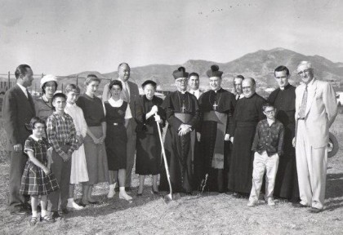](http://stambroseslc.com/wp-content/uploads/2014/03/school-groundbreaking.jpg)

[](http://stambroseslc.com/wp-content/uploads/2014/03/school-groundbreakingcropped.jpg)

The school was dedicated on July 28, 1957 and opened with six grades that Fall, under the direction of the Daughters of Charity. Sister Adelaide Kulhanek, D.C., was the first principal. Within a short time the school expanded to include all eight elementary grades and a kindergarten.

[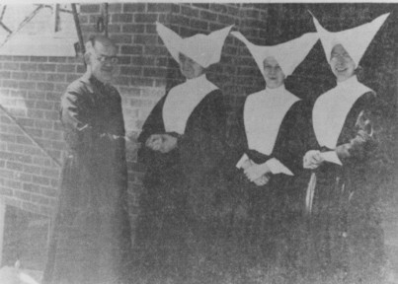](http://stambroseslc.com/wp-content/uploads/2014/03/Daughters-of-Charity.jpg)

The parish soon outgrew the church/hall combination and Sunday Masses had to be offered in the Cosgriff School gymnasium. After a long battle with illness, including the loss of both legs, Father Marceau went to the Lord on January 12, 1963.

[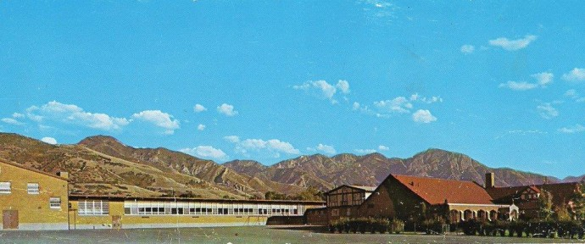](http://stambroseslc.com/wp-content/uploads/2014/03/stambrose-1960REVISED.jpg)

Succeeding Father Marceau as pastor was Monsignor William E. Vaughan, for twelve years previously the pastor of Sacred Heart Parish in Salt Lake City. He assumed his duties on February 22, 1963. Under his guidance, plans were initiated for a new and larger church.

Ground was broken on September 1, 1963, most of the former church/hall combination was razed and in its place a new church edifice and social hall were built. The first Mass was offered in the church on the Feast of Christ the King, October 25, 1964.

[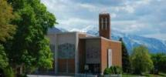](http://stambroseslc.com/wp-content/uploads/2013/05/chuch-photo-2.jpg)

The church, with its magnificent [windows](http://stambroseslc.com/our-windows/), incorporated many, but not all, of the liturgical directives of the Second Vatican Council then underway (1962-1965). The social hall underneath with stage and kitchen would serve for countless parish activities, receptions and programs. Under Monsignor Vaughan’s leadership the other Vatican Council decrees and directives were implemented in the parish. More participation and involvement by the laity in the workings and affairs of the parish became evident. A parish council and various lay ministries were established enabling greater service being provided to the parish at large.

[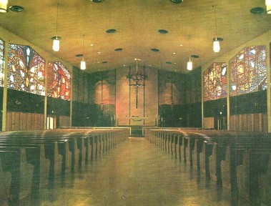](http://stambroseslc.com/wp-content/uploads/2014/03/old-interior-of-church.jpg)

In the summer of 1980, Bishop Joseph L. Federal, the recently retired sixth Bishop of Salt Lake City, accepted the retirement of Monsignor Vaughan as pastor of St. Ambrose and appointed Rev. John J. Hedderman, the Chancellor and Judicial Vicar of the Diocese, as the fourth pastor. Father Hedderman assumed the position on September 15, 1980 and Monsignor Vaughan, though relieved of pastoral responsibilities, continued his priestly ministry in the parish as Pastor Emeritus and continued to live in the rectory. In January 1981 the parish-owned duplex on the north side of the church parking lot was remodeled for a religious education office and several small meeting rooms. It was named Vaughan Center in honor of Monsignor Vaughan.

During the summer of 1982 a media center was added to Cosgriff School. This was completed prior to the celebration of the school’s 25th year of operation. Many programs and service out-reaches were developed in the 1980’s partially at the impetus of the parish council, which held annual weekend planning sessions, and partially under the leadership of the pastor. The pre-school religious education program was improved, the existing religious education program was enhanced with better trained teachers and coordinators, many of whom spent many months becoming degreed Master Catechists. A full-time, paid Director of Religious Education was hired as well as a full-time, paid Youth Minister to oversee the parish youth program. A part-time, paid liturgy/music director was employed to facilitate better worship.

[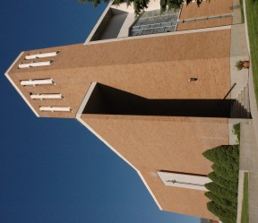](http://stambroseslc.com/wp-content/uploads/2014/03/st-ambrosefacebook.jpg)

The church building was completed and furnished before the Vatican Council liturgical decrees were promulgated, leaving it devoid of some necessary adaptations and unable to meet the contemporary needs of a post-Vatican II parish. Changes were necessary. After two years of planning, a parish-wide attitude survey, discussions, committee meetings and numerous education sessions, a church renovation/remodeling was begun in December 1987.

The sanctuary was re-designed with the altar being placed forward into the congregation, the rear entrance of the church was remodeled to include a gathering space for post-liturgy socials, the north sacristy was converted into a Blessed Sacrament chapel for daily Mass, a reconciliation room was added in the former baby chapel, a handicapped toilet was built in the social hall and an elevator installed for easier access to the social hall. Although renovation dedication was held on September 25, 1988, the entire renovation project lasted almost an entire year.

[](http://stambroseslc.com/wp-content/uploads/2014/03/old-interior-of-church.jpg)

On June 10, 1985, Monsignor William Vaughan celebrated his fiftieth year of priestly ordination. He continued to live in St. Ambrose rectory until March 1987 when ill health forced him to reside in St. Joseph’s Villa. Then on May 24, 1988, after almost 55 years of ministry to the people of Utah, Monsignor William E. Vaughan died.On January 13, 1988, Father John J. Hedderman was made a Prelate of Honor by Pope John Paul II, with the title of Monsignor.

[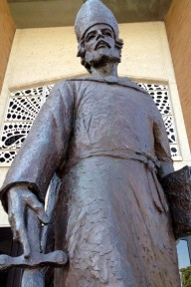](http://stambroseslc.com/wp-content/uploads/2014/03/St.-Ambrose-mel1.jpg)

A bronze statue of St. Ambrose, sculptured by Angelo Caravaglia, a local artist, was placed on a newly constructed concrete pedestal at the north rear church entrance. It aptly depicts the parish’s patron saint who, as a defender of orthodoxy against the Arians, was named a Father and Doctor of the Church.

In the summer of 1990, the convent chapel was remodeled into an art studio and science laboratory for the school. It was named the Marceau Studio/Lab after the second pastor of the parish. Also a computer laboratory was created out of part of the book storage area. Instruction in computer science as well as the use of computers had become a necessary part of the school’s curriculum.In June 1992, the Daughters of Charity were no longer able to provide sisters for Cosgriff School and the school had its first lay principal and an entire lay faculty and staff. The convent was leased by the Sisters of the Holy Cross.

In the summer of 1993, the school office was remodeled to accommodate an office for development. The operational costs of a Catholic school had so accelerated that a development office with various fund-raising programs became absolutely necessary.

[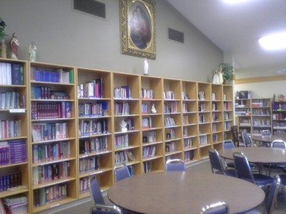](http://stambroseslc.com/wp-content/uploads/2013/05/Library.jpg)

In the summer of 1996, the Vaughan Center duplex was razed and a new, larger building constructed. It is still called the Vaughan Center but has two large rooms for meetings and extended day care, a kitchen, rest rooms and several offices for parish staff.In July and August of 1997 the Cosgriff School was seismically upgraded to withstand earthquakes of moderate scale. This upgrading involved a new roof, sheer steel interior walls, new lighting and a complete refurbishing of the school building.In the summer of 1998 the school was air-conditioned and the final upgrading completed. New playground equipment was installed.

The Holy Cross Sisters moved out of the convent and the building was used for the offices of the Bereavement\homebound director and the coordinator of volunteers. School aides also used rooms there for instruction.During 1999 a handicapped ramp was built in the north school hallway so access from the classrooms to the library, gym and computer room would be more readily available.In 2001 the convent was razed and the three-floor McCarthey Center was added to the school.

The Center houses an art studio, science lab, computer lab, music room, several offices, faculty lounge and youth gathering room. Named for former parishioners, now deceased, Thomas Kearns and Jane Finn McCarthey, whose family donated a third of the cost of the building. It has been a welcome addition to the school and the parish. On the top floor is Marceau Hall, a parish meeting room named for Rev. Valmore C. Marceau, the second pastor of St. Ambrose.

In June 2003 new double-paned windows were installed throughout the school replacing the old ones. The building is now cooler in warm weather and warmer in the cooler climes. After nearly 22 years, Msg. Hedderman retired. On January 1, 2004, Bishop George H. Niederauer appointed Rev. William F. Wheaton as Pastor of St. Ambrose. Rev. Gally Gregory Lourduraj later joined St. Ambrose as Associate Pastor. Msgr. John J. Hedderman died on October 4, 2005. On August 1, 2009, Bishop John C. Wester appointed Rev. Andrzej Skrzypiec as Pastor.

In September 2018, Rev. Joshua Santos was appointed pastoral administrator of St. Ambrose while Rev. Andrzej Skrzypiec was on leave. He served in this role until August 1, 2019, when Rev. Erik Richtsteig took over as pastor.

|  |  |  |
| --- | --- | --- |
| **CLERGY   OF ST. AMBROSE PARISH** | | |
| **Pastors** | |  |
|  | Msgr. Joseph I. Gosselin, | 1948-1956 |
|  | Rev. Valmore C. Marceau, | 1956-1963 |
|  | Msgr. William E. Vaughan, | 1963-1980 |
|  | Msgr. John J. Hedderman, | 1980-2003 |
|  | Rev. William F. Wheaton, | 2004-2009 |
|  | Rev. Andrzej Skrzypiec, | 2009-2018 |
|  | Rev. Erik Richtsteig | 2019- |
| **Associate Pastors & Other Priests Stationed At St. Ambrose** | | |
|  | Rev. Francis Lamothe, | 1952-1954 |
|  | Rev. Edmund J. Boyle, | 1954-1955 |
|  | Rev. Patrick J. Curran, | 1955-1958 |
|  | Rev. Norman A. Tkach, | 1958-1960 |
|  | Rev. James Fogarty, | 1960-1962 |
|  | Rev. Michael J. Winterer, | 1961-1963 |
|  | Rev. John B. Hart, | 1962-1965 |
|  | Rev. James Semple, | 1963-1965 |
|  | Rev. D. Patrick Pickford, | 1965-1966 |
|  | Rev. Philip M. Dahnken, | 1966-1968 |
|  | *Rev. Martin Semple, | 1967-1969 |
|  | Rev. John G. Kokal, | 1968-1970 |
|  | Rev. Liam Duggan, | 1970-1971 |
|  | *Rev. Charles E. Freegard, | 1971-1972 |
|  | Rev. Michael J. Donovan, | 1971-1973 |
|  | Rev. Patrick J. Carley, | 1973-1974 |
|  | Rev. William M. Mobley, | 1974-1976 |
|  | *Rev. John G. Kokal, | 1973-1976 |
|  | Rev. Paul R. Franco, | 1976-1979 |
|  | *Rev. Msgr. Jerome C. Stoffel, | 1981-1996 |
|  | Rev. Joseph M. Mayo, | 1980-1982 |
|  | Rev. David R. Gaeta, | 1982-1983 |
|  | Rev. Edward J. Konat, | 1983-1984 |
|  | Rev. David Van Massenhove, | 1984-1987 |
|  | Rev. Thuy D. Ha, | 1987-1989 |
|  | Rev. Thomas J. Kaiser, | 1989-1990 |
|  | Rev. Thomas L. Culleton, | 1991-1992 |
|  | Rev. Kenneth L. Vialpando, | 1993-1994 |
|  | Rev. Joseph Koch, C.M., | 1994-1998 |
|  | Rev. David J. Bittmenn, | 1998-2002 |
|  | Rev. Protas Swai, ALCP, | 2002-2003 |
|  | Rev. Stan Herba, | 2003-2004 |
|  | Rev. Louduraj Gally, | 2004-2009 |
|  | *Rev. Jerome Kim, | 2009-2013 |
|  | *Rev. Rowland Nwochocka, | 2013-2018 |
|  | **\*Denotes priest in residence** | |